MediCall: Design Foundations Document (DFD)

__________________________

*Deepthi Nacharaju, Lizbeth Leapo, Haeryn Kim*

**Section 1: Design Context Review**

In the United States alone, there are almost 36 million inpatient hospitalizations per year1 with an average stay of 4.5 days2. Many conditions can account for this staggering number of days spent in the hospital. The most common reason for this hospitalization is pregnancy, or neonatal in nature1. In the ages of 65+, these reasons include heart disease, osteoarthritis, and back problems, the latter two of which can have a large impact on a patient’s mobility1. As Americans spend increasingly large periods of time in hospitals, there should be an effort to make these stays as comfortable as possible.

During a time that can be scary, isolating, and stressful, people look to others for support and company. Though hospitals generally have visiting hours for family and friends to come see a patient, people often find themselves alone in their rooms. While patients are in inpatient care, they frequently need to call a nurse for help to use the restroom, eat, shift in their bed, and ask for medication. Rooms are usually set up with a call system, that can include a call bell, that enables the patient to alert their caregivers that help is needed. Beyond this, accessibility to reliable and efficient call bells reduces anxiety in the patient and increases family satisfaction with the stay3. Families are much more at ease leaving their loved ones in the hospital when they know a nurse is available nearby. Quick response times have even been shown to reduce fall risk and the incidence of pressure ulcers3. Nurses can help patients move from their bed to a chair and even the bathroom. Patients are also able to alert someone when they are uncomfortable from lying in the same position for too long. These are all important reasons why this line of communication is vital to a patient’s well-being.

There exist statewide regulations for the requirement of call bell or communication systems at nursing stations. For example, North Carolina has the following extensive requirement:

*“In general patient areas, each room shall be served by at least one calling station and each bed shall be provided with a call button[...] Calls shall register with the floor staff and shall activate a visible signal in the corridor at the patient's or resident's door[...]A nurses' call emergency button shall be provided for patients' and residents' use at each patient and resident toilet, bath, and shower”4*

The regulations go on to outline the number of call buttons required in rooms with multiple beds or bed stations, and even light indicators at corridor intersections. Other states, such as the state of Michigan, has no regulations regarding physical parameters of nursing stations4. In order for a solution to have potential market applications in the entire country, it must meet the most stringent of regulations, and in this case, encompass indicator lights and emergency buttons as well.

One study found the average number of calls placed by a patient to the nursing station to be 12 per day, with an increase in frequency around meal times5, perhaps to request help with trips to the restroom, or to ask for more food. Multiplying this value with the number of patients in a given unit – nurses receive 100 calls a day. With this high rate, the call bell must be reliable while also not cluttering the to-do list of nurses. A common complaint of the nurses in the study was that the high frequency of calls was disruptive to their busy shifts. Assessments, treatments, and teaching were now littered with patient calls5. There is a delicate balance between addressing immediate patient needs and tending to a longer term treatment plan composed of blood tests and imaging orders. Despite this, average response time was just 11 seconds5. This demonstrates that competing communication systems should be extremely efficient in transferring patient input, but also not be overly confusing, obtrusive, or disordered.

Current technologies include touch screens, hand held remotes, and pancake sensors for patients to create a user input. This signal is then translated to either a centralized screen at the nurses station, or a particular medical personnel’s handheld device3. Some systems even include a verbal system in which the patient indicates their specific need, and the receiver determines if the call should be routed to a registered nurse or to a nurse’s assistant4. Instead of just a generic call bell, some systems also indicate the specific need, and allow the user to choose from several common call requests. The patient lets the nurse know they need to use the restroom, change the channel, or shift their position remotely. What these systems typically seem to lack is feedback from the unit to the user that the call mechanism has been triggered. Because alertness or cognition in these patients, especially neurological patients, can be diminished, this feedback is vital to ensure that a purposeful call has been triggered or than an accidental one has not been placed. On the other hand, some sensors are too easily triggered, calling for nurses when the patient was merely shifting in their bed. This leads to further frustration, and nurses and patients often throw the call system aside altogether.

Physical sensors like these are often limited to use by patients with full mobility and dexterity in their hands. The systems that require verbal input are limited to those who can speak loudly and clearly. Finding a suitable system for patient populations with limited speech or physical capabilities remains a challenge.

Patients in the Neurocritical Care Unit of the Duke Medicine Pavilion, or DMP, suffer from a wide range of ailments that vary in severity and also vary the length of each stay. Frequently, patients have suffered from strokes, resulting in paralysis that ranges from monoplegia to quadriplegia6. Some patients have considerable dexterity in their upper extremities, while others are completely paralyzed and can barely speak or see. Loss of function in the arms and legs can be especially dangerous because the patient is not able to catch his or her falls, rotate to ease pain from lying on their backs for long periods of time, or move to the restroom. Paralysis can also result from other neurological diseases, including physical trauma, neuropathy, and Parkinson’s Disease. The loss of any important functions limits accessibility to remotes with several buttons, or verbal cues.

Similar limitations can be found in other clinical populations, including young people suffering from orthopedic injury, and middle-aged patients battling cancer. This creates a larger context for the relevance of this issue. Outside of neurological units, loss of motor skills can be prevalent in oncology, trauma, and cardiac centers across the country. Any patient that is admitted to the hospital, could potentially find him or herself too weak or entirely unable to lift their arms, while simultaneously at need of frequent attention and care. In any combination, these limitations can be extremely detrimental in calling for help and could result in increased risk of death or serious injury.

At the Duke Medicine Pavilion, there are several adapted call bells in place, three of which are pictured below in Figure 17. These include the standard call bell with a button on the patient’s TV remote, a handheld push-button call bell, and a pancake call bell. The push-button and pancake call bell are used for patients with a larger degree of physical or cognitive impairment.

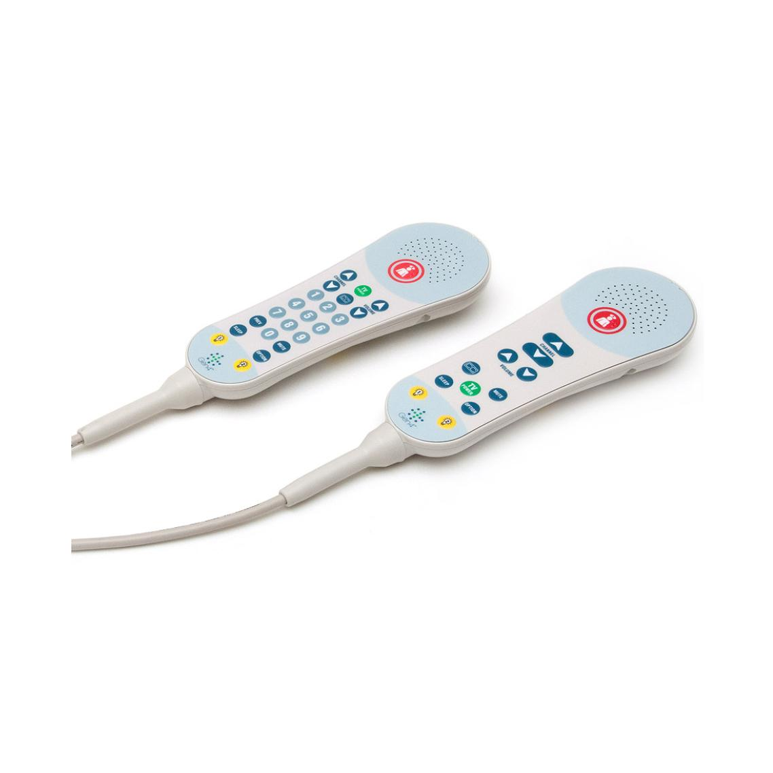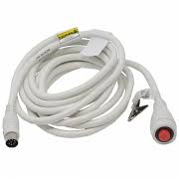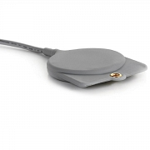

**Figure 1.** Call bells implemented in the Duke Medicine Pavilion. From left to right, the standard TV remote call bell, the handheld push-button call bell, and the pancake call bell13.

After observing the use of these devices in the Neurocritical Care Unit of the DMP, it became evident that while there are adapted call bells for patients with specific physical or cognitive needs, several factors still result in faulty patient-to-nurse communication. The standard call bell is designed for patients with very few physical or cognitive limitations. However, this bell is also often provided to patients with visual impairments who struggle to differentiate the call bell button from the TV remote buttons. Nurses sometimes attach ECG leads to the call bell button on the remote to make it easier for those patients to use the call bell function. The push-button call bell works well for patients with a relatively high degree of hand dexterity, but the button has no stand, and often gets dropped on the floor or lost in the hospital bedding. The button also has no feedback mechanism to alert the patient that it has been activated. This generally leads to a high number of false pages to the nurses’ station. The pancake sensor has a similar problem. It is designed for patients with very limited hand dexterity. However, it is extremely sensitive and does not have a feedback mechanism. According to Kim Powell, a speech pathologist who works in the Neurocritical Care Unit, the pancake sensor is far too sensitive to be used effectively and it results in the largest amount of false alerts.

Each call bell in a patient room, regardless of the type of call bell, is connected first to a station on the patient’s ECG cart, and then to a wall power supply. One of the largest failures of the call bell system at the DMP is the lack of attention in plugging in *both* of these connections. This also dramatically reduces patients’ accessibility to nurses when in need.

It is critical that patients are able to contact nurses when they are in need of assistance. Patients with limited hand dexterity find both standard and adapted call bells at Duke to be particularly unhelpful. The systems are either physically inaccessible, unplugged, or too sensitive. The ultimate challenge is addressing all of these inconveniences with one device or system.

Our primary need is to find a way to address inadequate patient-to-nurse communication in patients with limited hand mobility that increases accessibility to nurse assistance while reducing the number of false alerts caused by current call bell systems.

**Section 2: Market Analysis**

In the context of this problem, there were two ways to segment the available market. The first was according to medical unit or service provider the patient would seek out to receive care. The market includes smaller segments such as palliative care units, surgical in-patient clinics, and at home care.

The target segments of focus include Nursing and Retirement homes with a predicted total addressable market (TAM) of $42,228,0008,9 and Neurocritical Care Units (NCUs) with a TAM of $262,80010,11. The primary criteria used to determine the target segment includes a target population that experiences limited mobility of their upper extremities, with potential limitations in speech, sight, and cognition.

Care systems for the elderly regularly take care of people at the end of their life. In this stage, people experience declines in both physical and mental health, demonstrated by decreases in balance, dexterity, muscle strength, and mental sharpness. These people would also experience potential challenges with using traditional call bell systems. In the United States, the entire population of nursing and retirement homes includes 15,600 Nursing homes with 1.7 million beds9. This translates to about 109 beds per facility and a need for an equivalent number of call bells. In order to determine their willingness to pay, competitive products were analyzed for cost per unit.

Competitive products can be found in Table 1, below. Each system was broken down into per patient room costs. For example, a system that cost $1,000, but supplied 10 individual modules, was translated to a $100/bed cost. On average, the cost per bed was $150. To calculate predicted Total Addressable Market (TAM), the number of estimate beds per segment in the US was multiplied by the cost per bed. For the Nursing/Retirement home segment, there are estimated number of 15,640 homes with an average of 108 beds. The total of 1,689,120 beds was multiplied by $150/bed for a TAM of $42,228,0008,9.

NCUs also care for a patient population with physical and mental limitations. NCUs typically treat acute ischemic strokes, cases of meningitis, traumatic brain injury and cerebral aneurysms, along with a host of other potentially fatal conditions. Patients experience varying levels of consciousness and frequently need to alert a nurse when they are awake. However, with this level of brain injury, many patients experience spastic or disjointed movements of their extremities. Across the country there are 73 of these units10. Similar conditions can be also found in Neurology units, which are found more frequently in hospitals. Estimating the number of beds per unit to be around 24, coming from the number of beds in Duke University’s Neurological ICU9, to total number of beds in the US as 1,752. Again, multiplying cost per bed equates to $262,80010,11.

To further narrow down the target population, these segments were refined by considering the physiological limitations of the patients. This is the second way in which this market could be segmented. In general, there are three overarching themes to what created challenges while trying to utilize the traditional call-bell system, both in the larger scope of disabilities and in the Duke Medical Pavilion Neuro ICU client. These themes include cognitive impairments, when the patient lacks awareness or alertness to understand how a traditional button system works. The patients could also experience sensory loss, in which blindness prevents them from seeing the difference between various buttons on a remote. Another limitation is more physical in nature, where either paralysis or jerky movements have trouble exhibiting the dexterity needed for traditional call-bell systems.

After thorough market analysis, the primary target market segment will be those experiencing challenges with the mobility of upper extremities in Nursing/Retirement homes and Neurocritical Care Units, with potential for extension into other segments given success with this group.

**Section 3: Identifying Customer Needs**

Kim Powell is a clinical expert at the cross section of healthcare and communication, and a speech pathologist in the Neuroscience Department at Duke Hospital. She specializes in stroke recovery, and many of the devices in her unit are tailored to patients with limited hand dexterity, poor cognitive ability, or paralysis. Ms. Powell expressed the limitations of the sensitive adaptive devices such as the push-button and pancake call bells. She conveyed frustration with the wiring of the current call bell system and facilitated an introduction to a stroke patient who provided insight into image comprehension limitations post-stroke.

Observations during the shadowing visit led to the conclusion that the call-bells in the unit were either too sensitive and sent false alerts to nurses, or that they were entirely unused because they were either unplugged or physically inaccessible to the patient. There was a need to reduce the amount of excessive wiring attached to the call bell, so that it was accessible when needed, but not in the way otherwise. Patients with cognitive limitations also need a clear indication that the call-bell is activated, because the current devices do not provide any mode of feedback. The full list of customer needs is provided in Table 1 below.

**Table 1.** Identified Customer Needs

|  |  |  |  |
| --- | --- | --- | --- |
| **No.** | **Type of Need** | **Need** | **Priority** |
| 1 | Patient | Device is easily accessible for patients with limited hand dexterity | 1 |
| 2 | Patient | Device provides some mode of feedback when activated | 2 |
| 3 | Patient | Device will not be in the way when not in use | 3 |
| 4 | Nurse | Device transmits the signal to multiple receivers | 2 |
| 5 | Nurse | Device quickly transmits the signal to nurses | 2 |
| 6 | Nurse | Device reduces the amount of false alerts going to the nurses' station | 2 |
| 7 | Nurse | Device is durable and can withstand accidents | 5 |
| 8 | Nurse | Device reduces excessive wiring | 2 |
| 9 | Payer | Device has similar cost to other competitive nurse call systems | 4 |
| 10 | Payer | Device can be produced and purchased in bulk so hospitals can use in each patient room | 5 |
| 11 | Regulatory | Device complies with nursing units regulations set by NC | 2 |
| 12 | Regulatory | Device does not cause any adverse health effects, or pose a trip or fall hazard to the patients | 3 |
| 13 | Regulatory | Software on the device should meet IEC Medical Device Software Standards | 5 |

The customer needs are organized into patient needs, nurse needs, payer needs, and regulatory needs. This device has two primary users: the patient and the nurse. The patient needs deal with accessibility and use of device, while the nurse needs deal with the transmission and reliability of the alert in itself. The payer, Duke Hospital, needs this device to have a similar cost to competitive call systems. In terms of regulatory standards, the call system must comply with software and safety regulations met by the Duke Medicine Pavilion.

In establishing a hierarchy for our customer needs, increasing patients’ accessibility to nurses is a higher priority than reducing the amount of false alerts sent to nurses. The risk of a patient unable to get medical attention supersedes the inconvenience of a false alert. It is also important that the device provides some sort of feedback, which allows for easier use by patients with cognitive limitations, and subsequently reduces the amount of false alerts because it prevents repetitive pushing. Meeting state regulations for nursing units is also critical to ensure potential usage of our device in hospital rooms. Long-range and fast signal transmission was prioritized over durability, because an effective and fast alert is most beneficial to the patient and nurse. Reducing the amount of wires is a medium priority, because it is more of an inconvenience than a significant risk. Cost-efficiency and meeting software standards were of lowest priority because we first want to establish an effective and reliable device.

**Section 4: Design Specifications**

In order to reliably quantify the accuracy with which our product serves the customer needs, the following design specifications were determined to serve as quantitative judgment criteria.

**Table 2.** Target Specifications

|  |  |  |  |  |  |  |
| --- | --- | --- | --- | --- | --- | --- |
| **Spec. No.** | **Need Nos.** | **Specification** | **Units** | **Competitive Value** | **Marginal Value** | **Ideal Value** |
| 1 | 3, 8, 12 | Wires from device to power | Number | 1-2 | 1 | 0 (wireless) |
| 2 | 1, 2, 11 | Modes of button feedback (buzzing/light/sound) | List | 0 | 2 | 3 |
| 3 | 4 | Signal transmission range | m | 150 | 200 | 300 |
| 4 | 8 | Battery life | months | 0 (connected to wall power) | 2-3 | 6 |
| 5 | 7 | Water resistance | Standard | IPX5 | IPX4 | IPX5 |
| 6 | 1 | Weight of device | g | 110 | 100 | 50 |
| 7 | 9, 10 | Cost of device | $ | 150 | 100 | 70 |

The units include simple tallies (denoted as ‘numbers’), statistical values obtained through trials (in percentage), and categorization by standards. Standard pertains specifically to the requirements for water resistant devices as defined by the IP code, provided in the International Electrotechnical Commission (IEC) standard 6052912. Whereas the search for comparable products did not provide their IP levels, we could narrow down the desired liquid ingress protection for our product. IPX5 means the device would be protected from a low level stream of water at any angle12.

These criteria were determined by brainstorming the metrics associated with specific customer needs.To ensure that patients or nurses can easily access our product we wanted to make sure that it was easy to find and within reach, which is measured by the time it takes to find and activate the device. Current technologies at the DMP currently do not have feedback mechanisms, so a quantitative measure of types of feedback such as vibration, light, and sound was added as a specification. This specification also addresses the state regulation requiring a visible signal for nursing call units4. To address excessive wiring, the number of connections the device has to a wall plug or a source of power is a major specification. Some specifications were necessary to cover the basic functions of a call bell such as notifying the nurses within a reasonable range. The only customer need that was not matched by these quantitative specifications was the software regulation need (13), because this would require a qualitative check of the software.

Furthermore, we researched comparable products on the market and their design specifications to complement our specifications, as well as competitive values. For instance, the competitive value of cost was an averaged price projected on the nurse call products catalog of healthcare facilities companies13. Competitive values of weight were similarly found from comparable call bell products detailed in the market analysis. Competitive values for false alert rates were found in literature on alarm fatigue14. Ideal values were subjectively determined as the best possible values, without considering any scope or limitations of the project. Marginal values were determined as mid-range values between the competitive and ideal. For instance, whereas most systems were comprised of a base station dependent on wall plugs and pagers running on batteries with more than 6 months of battery life, 2-3 months of peak operation time were deemed as reasonable for our standalone, wireless communication device. Ideally, the device would be wireless with long battery life, water resistant, cheap, accessible in less than a minute, and have multiple modes of feedback.

Citations

[1] McDermott, K. W., Elixhauser, A., & Sun, R. (2017). Trends in Hospital Inpatient Stays in the United States, 2005-2014. Healthcare Cost and Utilization Project. https://www.hcup-us.ahrq.gov/reports/statbriefs/sb225-Inpatient-US-Stays-Trends.jsp

[2] Weiss, A. J., & Elixhauser, A. (2014). Overview of Hospital Stays in the United States, 2012. From Healthcare Cost and Utilization Project. https://www.hcup-us.ahrq.gov/reports/statbriefs/sb180-Hospitalizations-United-States-2012.pdf

[3] Galinato, J., Montie, M., Patak, L., & Titler, M. (2015). Perspectives of Nurses and Patients on Call Light Technology. Computers, Informatics, Nursing : CIN, 33(8), 359–367. http://doi.org/10.1097/CIN.0000000000000177

[4] Statewide Regulations for Nursing Units. (2011). *Health Policy and Management.* <http://www.hpm.umn.edu/nhregsplus/NH%20Regs%20by%20Topic/NH%20Regs%20Topic%20Pdfs/PE%20-%20Nursing%20Unit/category_pe_nursing%20unit%20state%20regulations.pdf>

[5] Roszell, S., Cheryl B. Jones, & Lynn, M. R. (2009). Call Bell Requests, Call Bell Response Time, and Patient Satisfaction. Journal of Nursing Care Quality, 24(1), 69-75. doi:10.1097/01.NCQ.0000342938.99036.9f

[6] Divani, A. A., Majidi, S., & Barrett, A. M. (2011). Consequences of Stroke in Community-Dwelling Elderly: The Health and Retirement Study 1998-2008. *Stroke., 42*(7), 1821-1825. doi:10.1161/STROKEAHA.110.607630

[7] Nurse Call. *Medline.* Retrieved from https://www.medline.com/category/Nurse-Call/Z05-CA15_12_02_07

[8] Smart Caregiver Two Call Buttons & Wireless Caregiver Pager. https://www.amazon.com/Smart-Caregiver-Buttons-Wireless-Pager/dp/B0032FMSWS

[9] Nursing Home Care. (2014). From Centers of Disease Control and Prevention. https://www.cdc.gov/nchs/fastats/nursing-home-care.htm

[10] Ward, M., Shutter, L., Branas, C., Adeoye, O., & Carr, B. (2012). Geographic access to US Neurocritical Care Units registered with the Neurocritical Care Society. *Neurocritical Care, 16*(2), 232-240. doi:10.1007/s12028-011-9644-2.

[11] Neurocritical Care Unit, Duke Medical Pavilion, 8E. *Department of Neurology- Duke University School of Medicine.* https://neurology.duke.edu/divisions/critical-care-and-vascular-neurology/neurocritical-care-unit-duke-medical-pavilion-8e

[12] International Electrotechnical Commission. (2013). *Degrees of protection provided by enclosures (IP Code)* (Standard No. 60529). Retrieved from https://subscriptions.techstreet.com/products/653435

[13] Curbell Medical. (2017). ‘Nurse Call and Healthcare Bed Accessories.’ Retrieved from <https://curbellmedical.com/wp-content/uploads/pdfs/nurse_call/map466d_curbell_nurse_call_and_bed_products_catalog.pdf>

[14] Jones, K. (2014). Alarm fatigue a top patient safety hazard. CMAJ- JAMC, 186(3), 178. doi: 10.1503/cmaj.109-4696